# Chapter 4: Implementation (Coding)

## Introduction

This is the third phase of Structured System Analysis & Design Methodology (SSADM). Here, the system is directly introduced to an organization or run parallel with the existing system unless a new system works successfully.

In this phase, coding is also done. Here design model that shows how our systems look and work is converted into actual products. In the process of coding have used MVC design pattern which separate code into Model, View, and Controller. That directly helps in making code having less coupling and more cohesion.

## 4.1 Importance of coding:

* Coding helps us to write code which is efficient and easy for us to understand, read and write.
* With the help of the coding application, website, and so on are more easy and efficient to understand.

## 4.2 Tools Used:

To complete my project successfully some database software and Integrated Development Environment(IDE) tools are used for storing data and to write code for the development of the website. Which are:

For Database

* Xampp
* MySql

For Integrated Development Environment (IDE)

* NetBeans

## 4.3 Language Used

As for the successful development of my project, I have used different frontend and the backend language which are:

Back end Language:

* Java

Font end language:

* Hypertext Markup Language (HTML)
* Cascading Style Sheets (CSS)
* Javascript

## 4.4 Codes

Admin Home

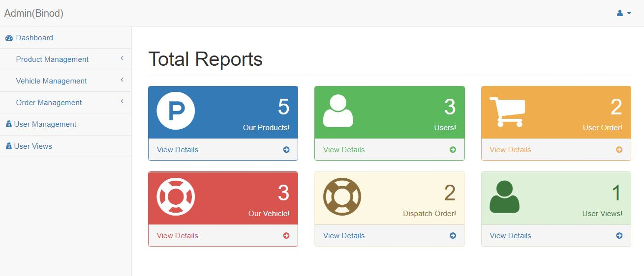

Screenshot: Admin Home

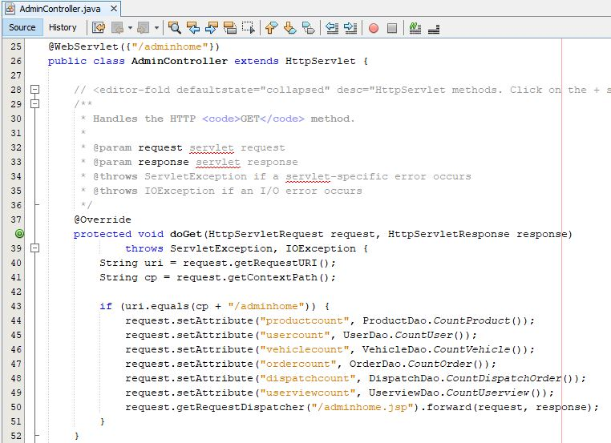

Screenshot: Controller for Admin Home

Admin manage product

Model for product

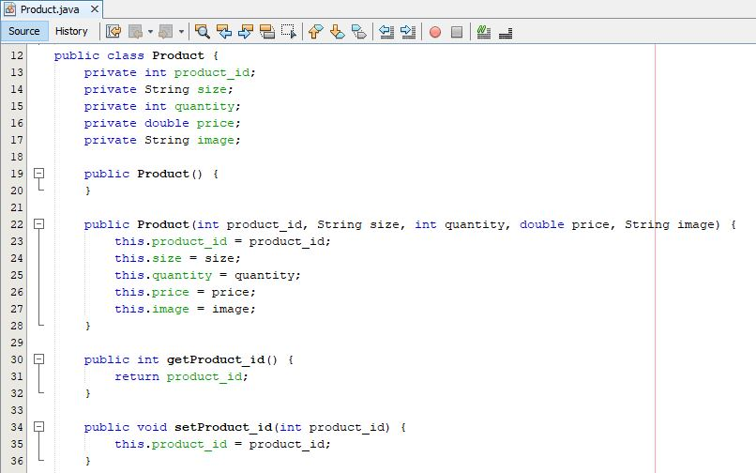

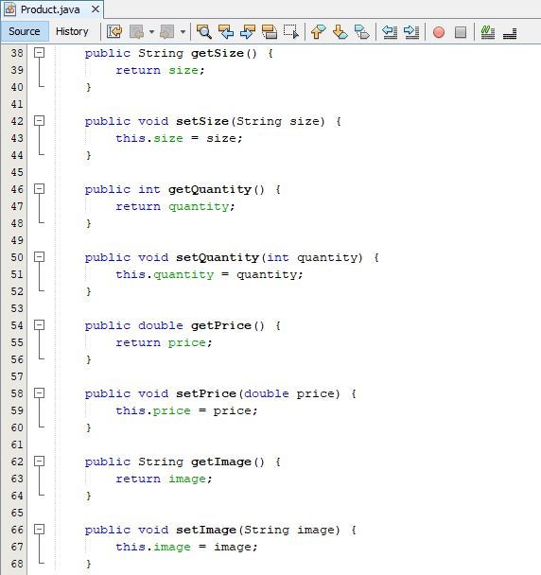

Controller for product

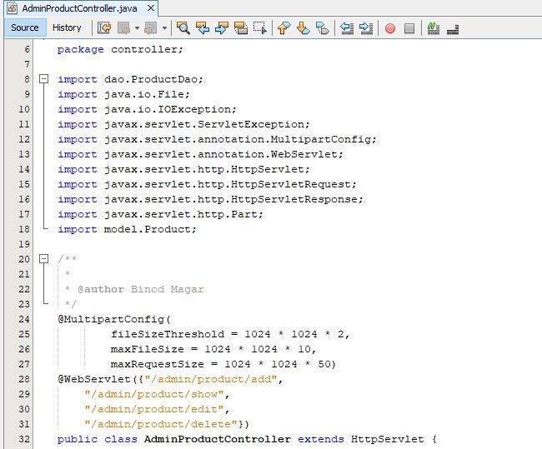

Screenshot: Imported Library and URL(Uniform Resources Locator) pattern for Product Controller

Admin product controller request in doGet and operation performed

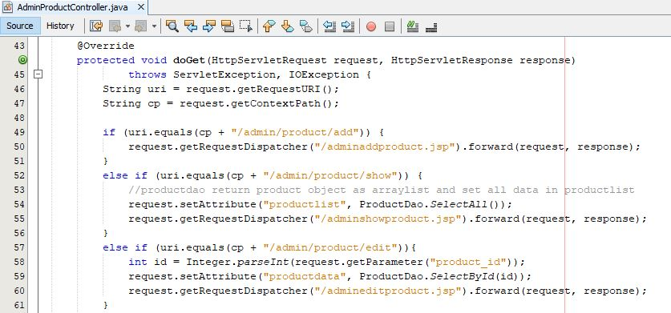

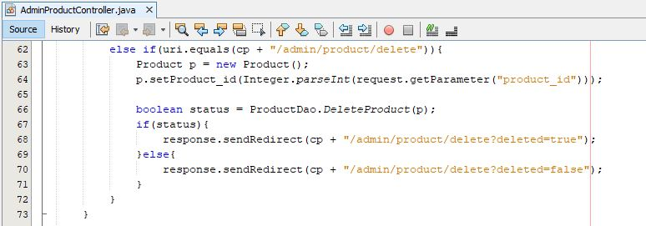

Admin product controller request in doPost and operation performed

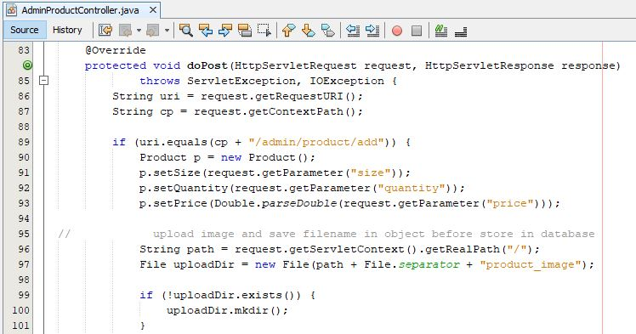

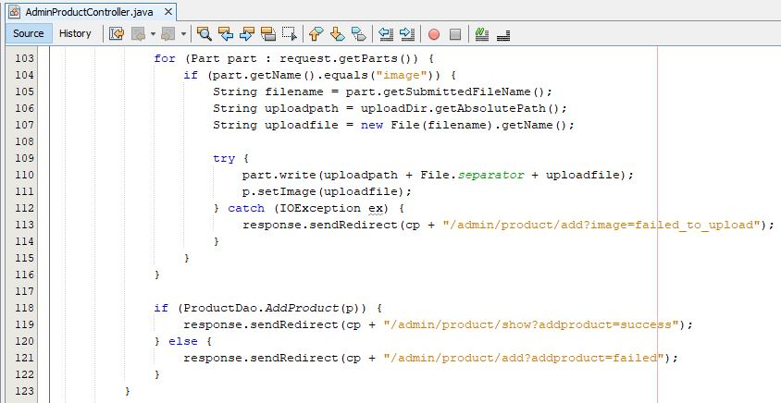

Screenshot: Controller to add product

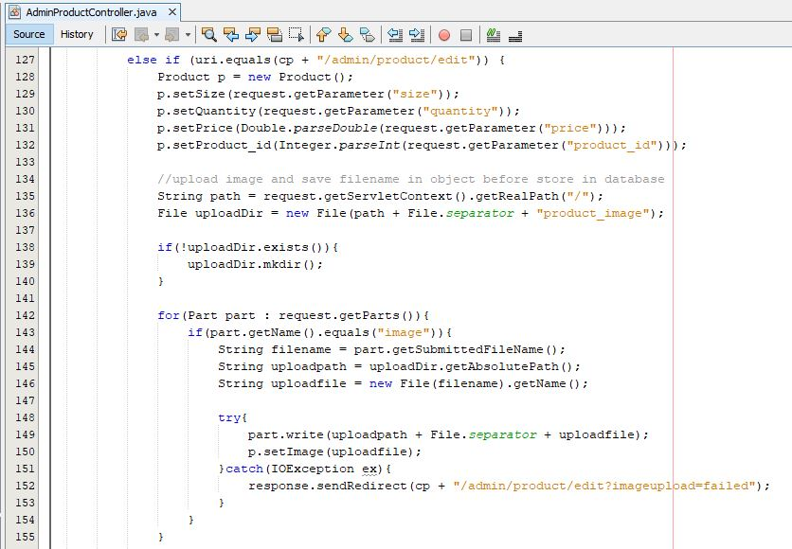

Screenshot: Controller to edit product

Admin product DAO(Data access object)

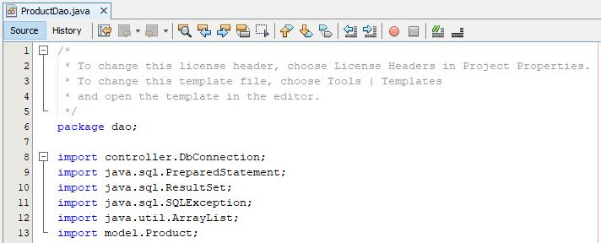

Screenshot: Imported library for productDao

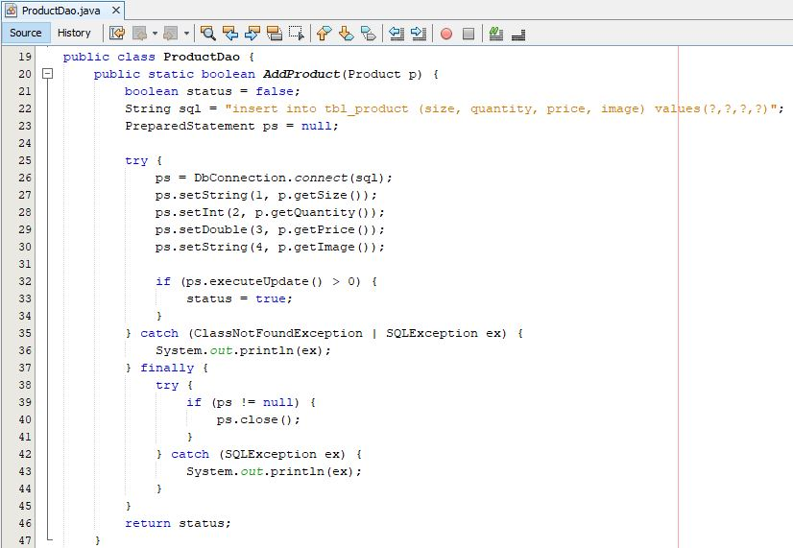

Screenshot: ProductDao of adding of product

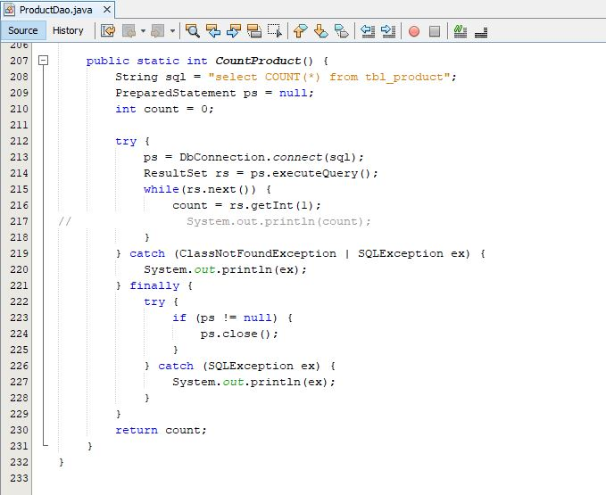

Screenshot: ProductDao for count total product

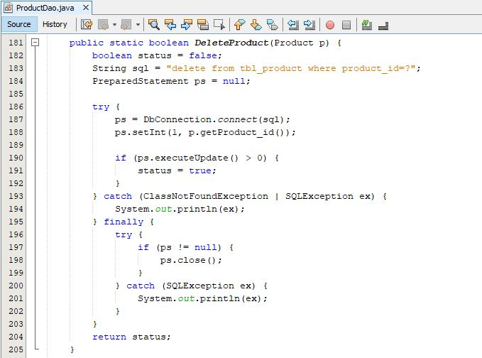

Screenshot: ProductDao to delete product

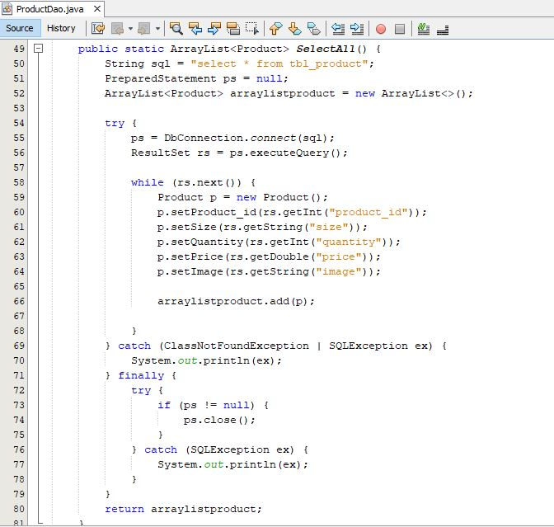

Screenshot: ProductDao to select all product in ArrayList

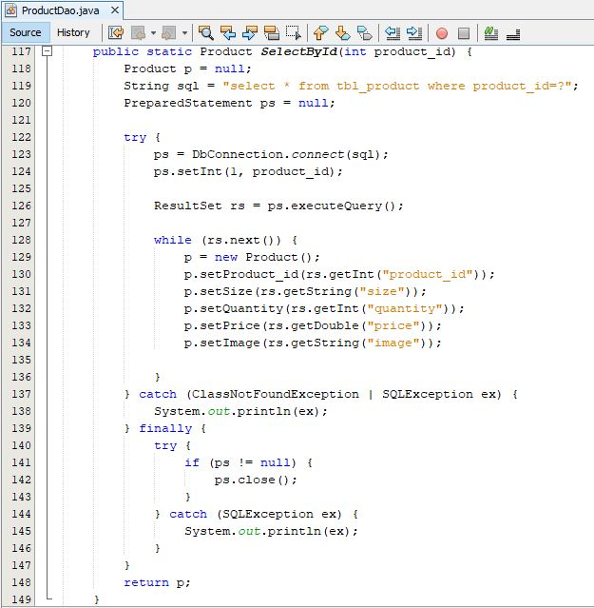

Screenshot: ProductDao to select product by product id

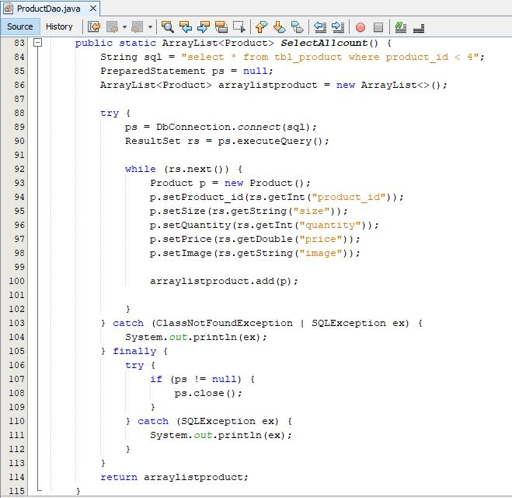

Screenshot: ProductDao for select product id less than 4

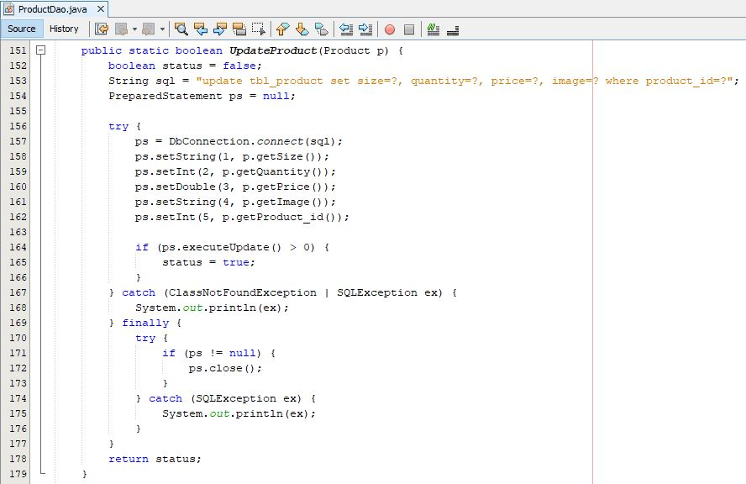

Screenshot: ProductDao to update product

Form for Admin manage product

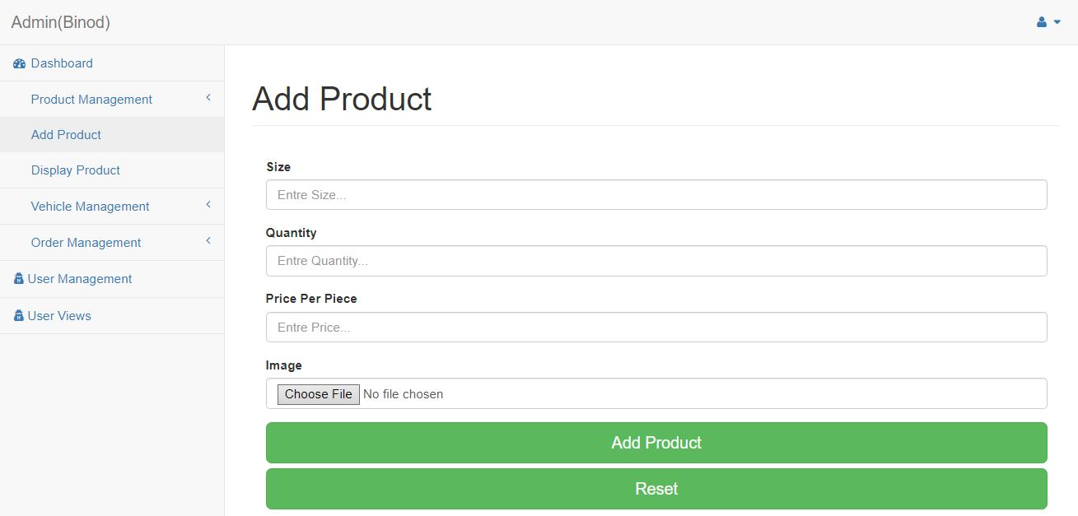

Screenshot: Form for add product

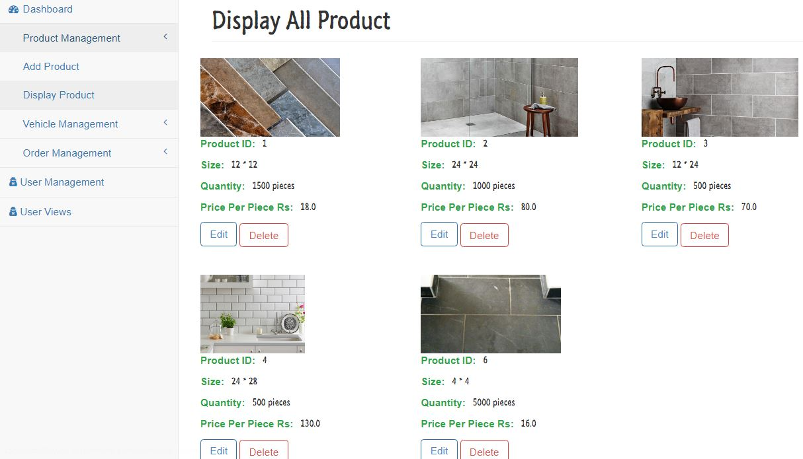

Screenshot: Display of all product

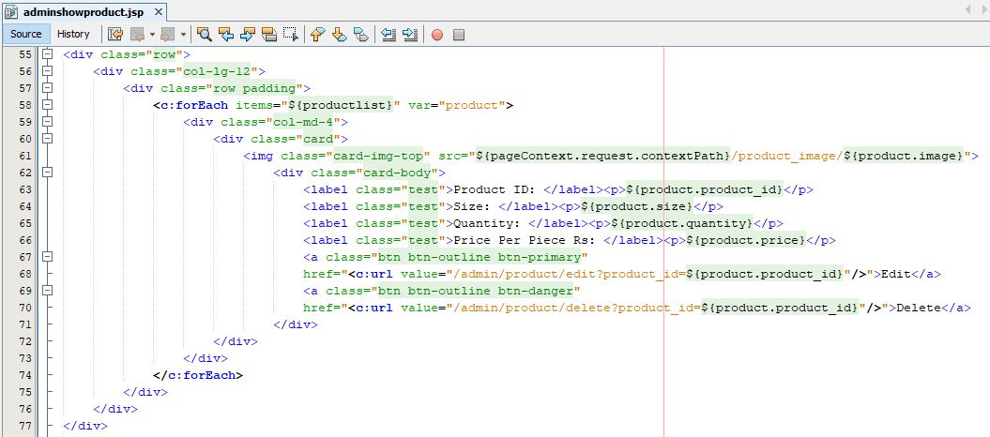

Screenshot: JSP file for display all product

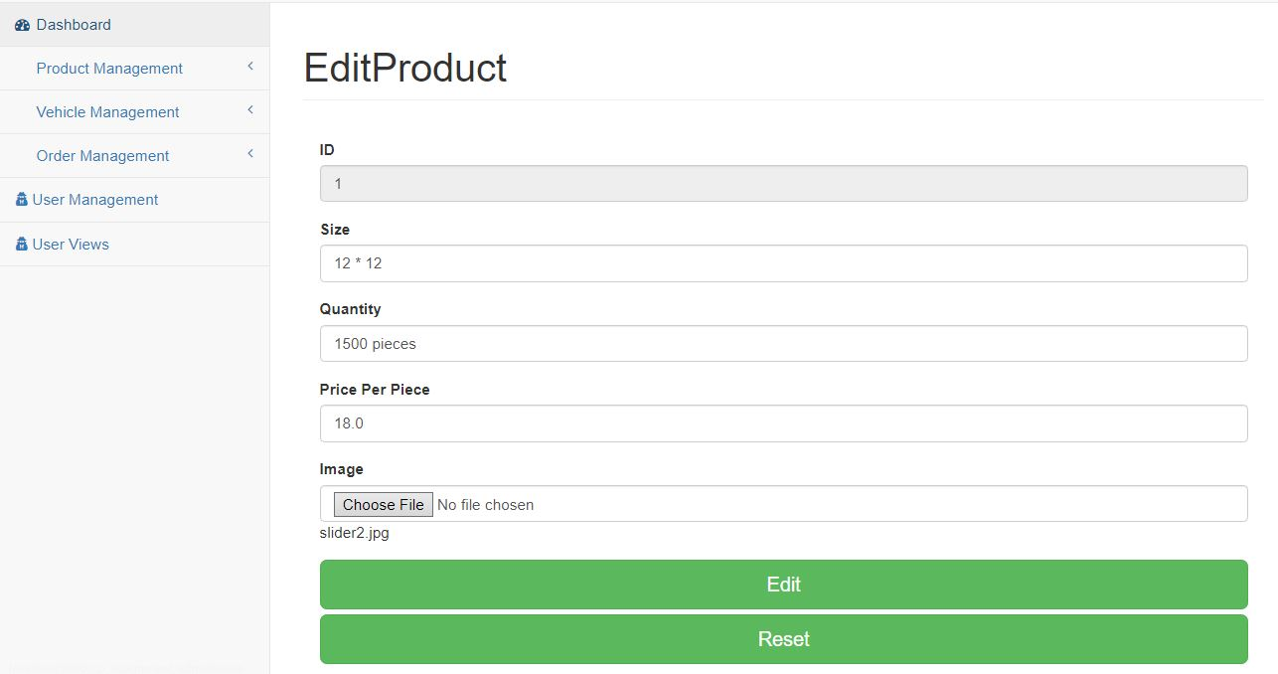

Screenshot: Form to edit a product by admin

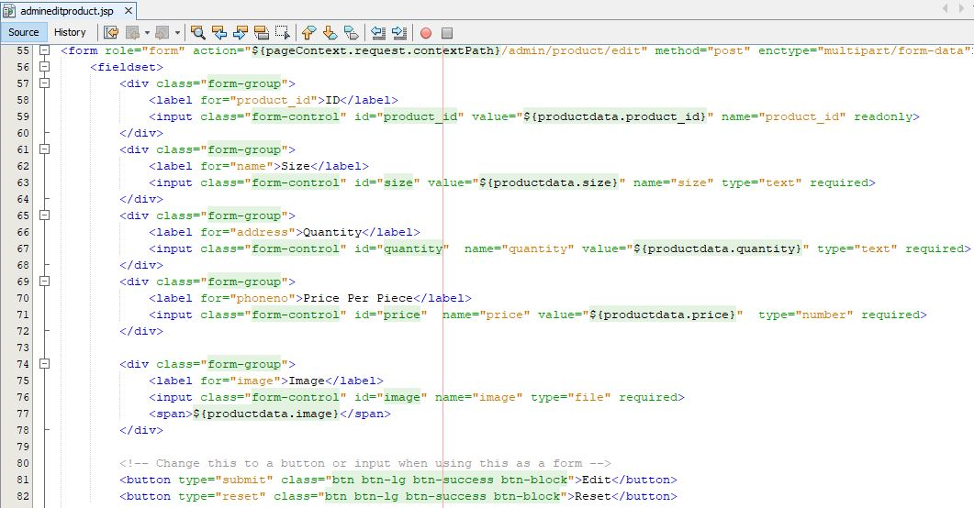

Screenshot: JSP(Java Server Page) to edit product

Admin manage vehicle

Model for vehicle

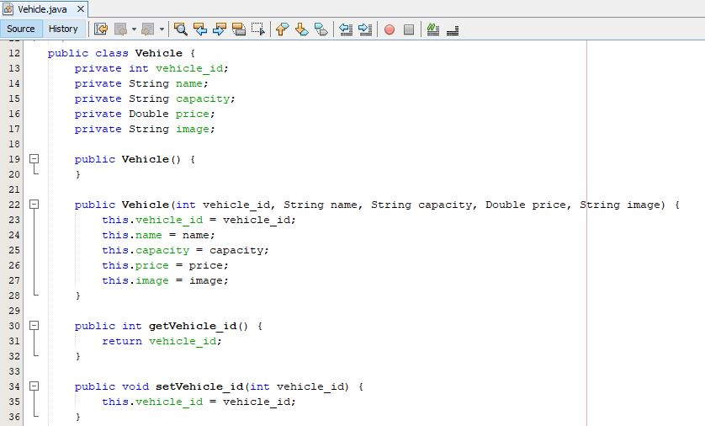

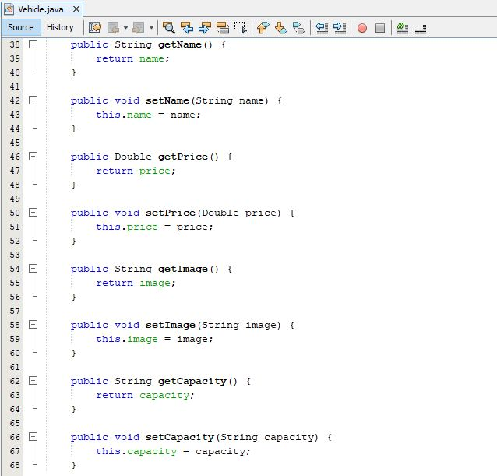

Controller for Vehicle

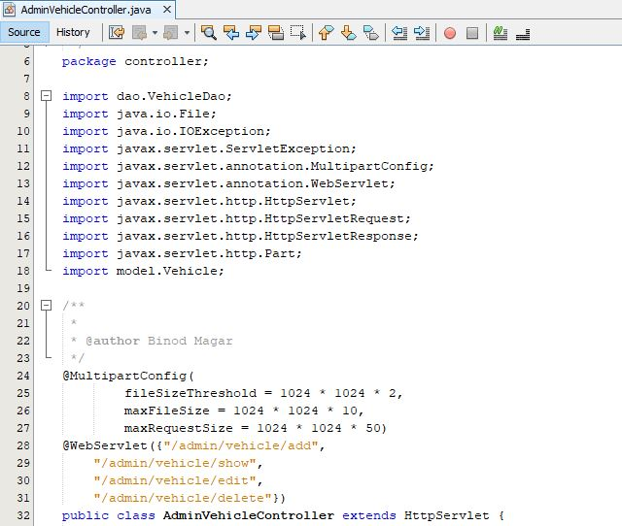

Screenshot: Imported Library and URL(Uniform Resources Locator) for Vehicle Controller

Admin vehicle controller request in doGet and operation performed

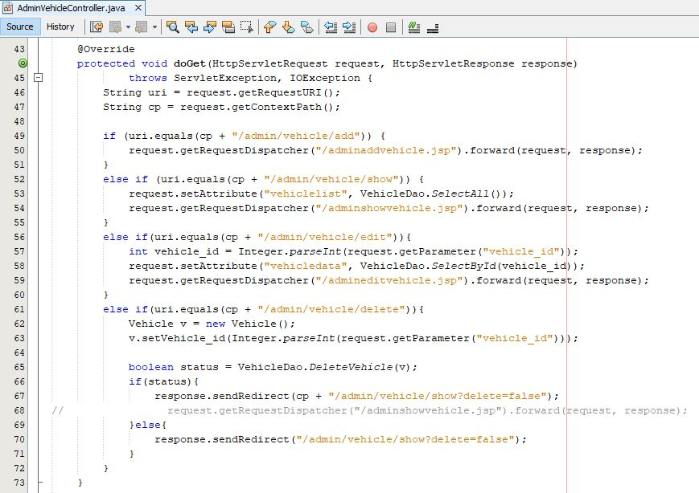

Admin vehicle controller request in doPost and operation performed

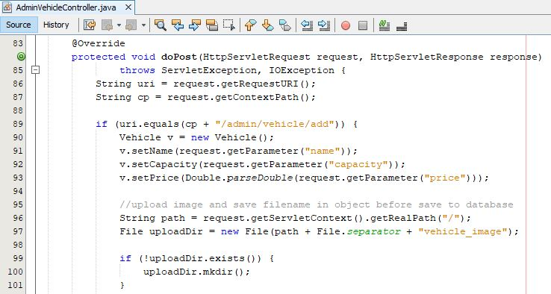

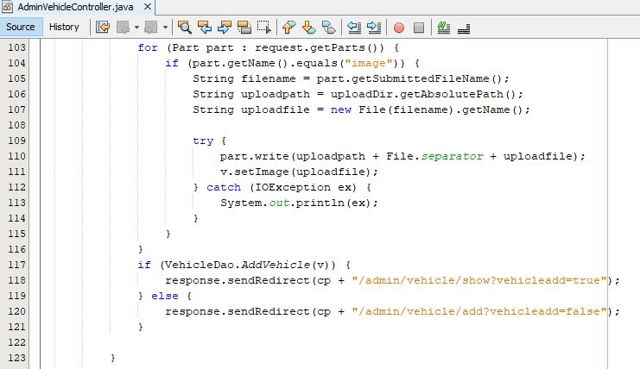

Screenshot: Controller to add vehicle

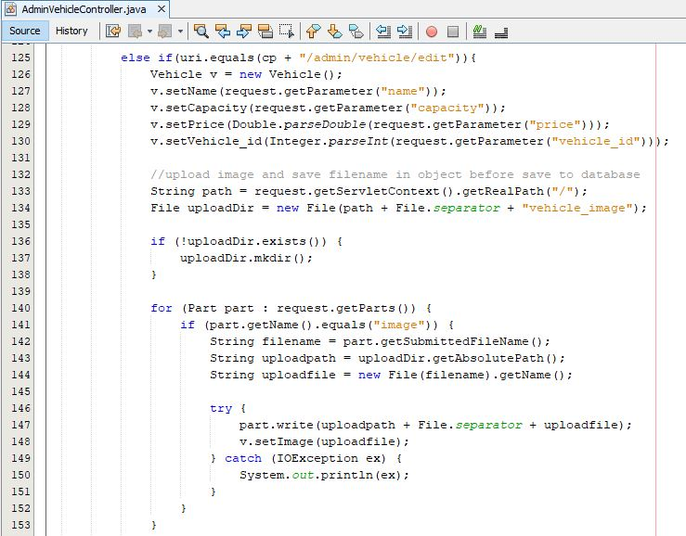

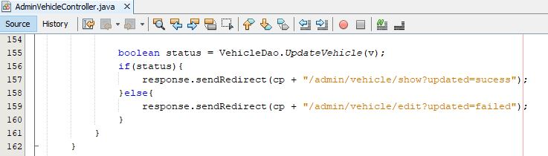

Screenshot: Controller to edit vehicle

Admin Vehicle Dao(Data access objects)

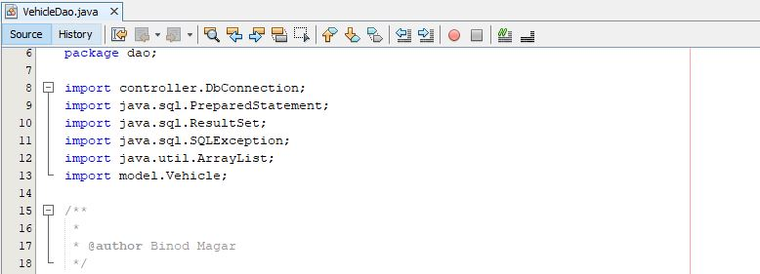

Screenshot: Imported library for vehicle dao

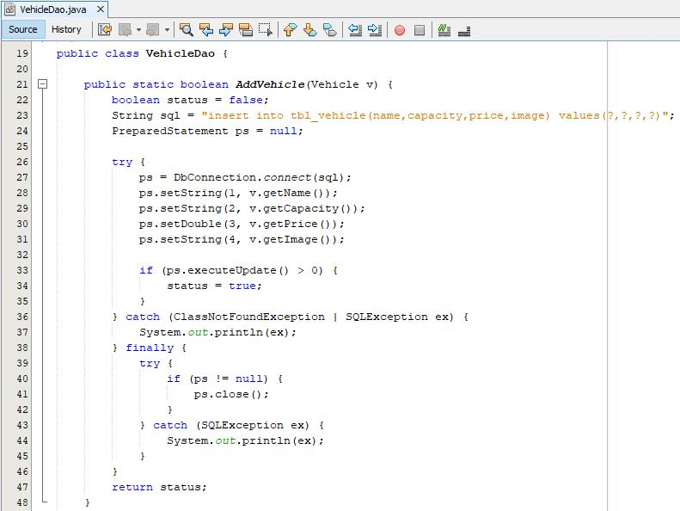

Screenshot: Vehicle dao to add vehicle

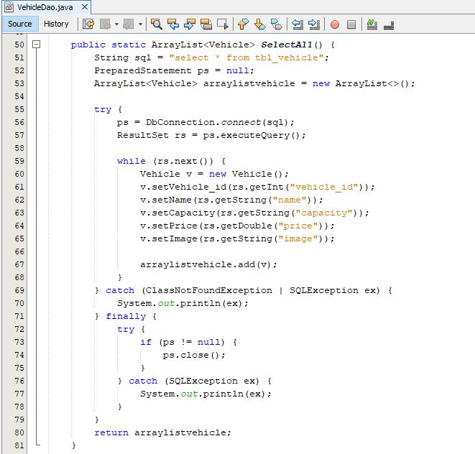

Screenshot: Dao to select all vehicle and store in ArrayList

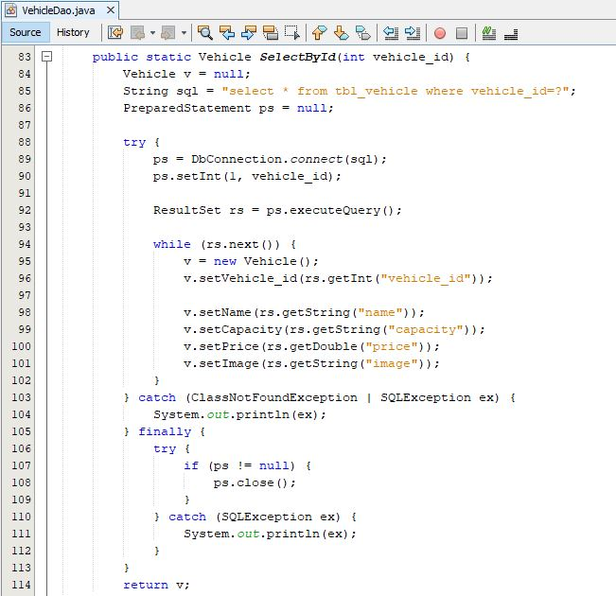

Screenshot: Dao to select vehicle by vehicle id

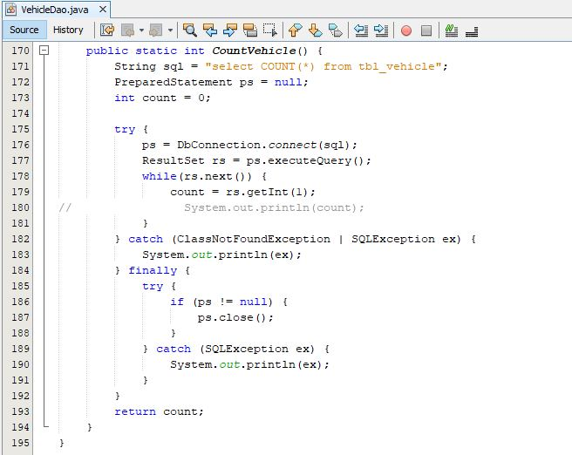

Screenshot: Vehicle dao to count all vehicle

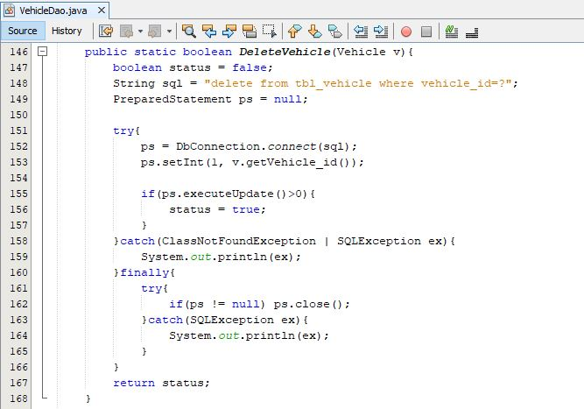

Screenshot: Vehicle dao to delete vehicle

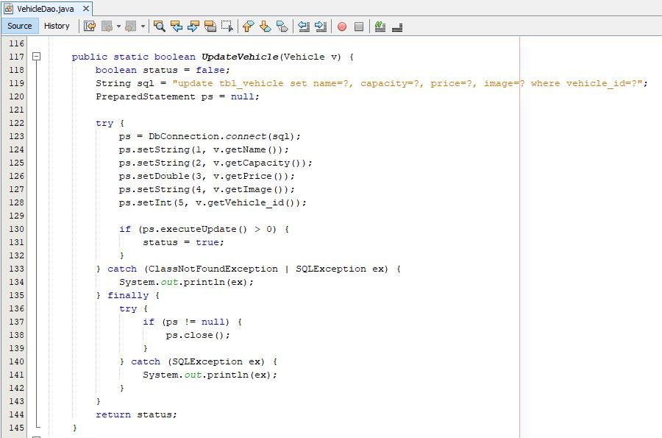

Screenshot: Vehicle dao to update vehicle

Form to manage vehicle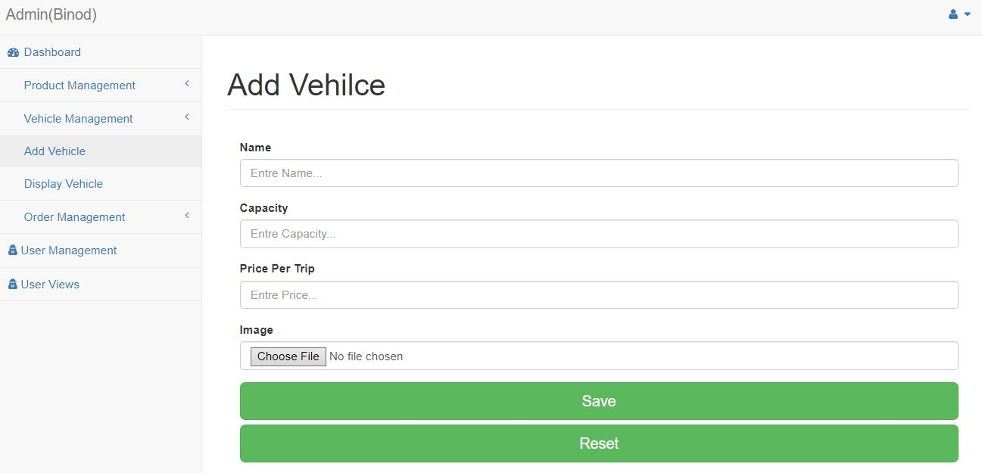

Screenshot: Form to add vehicle

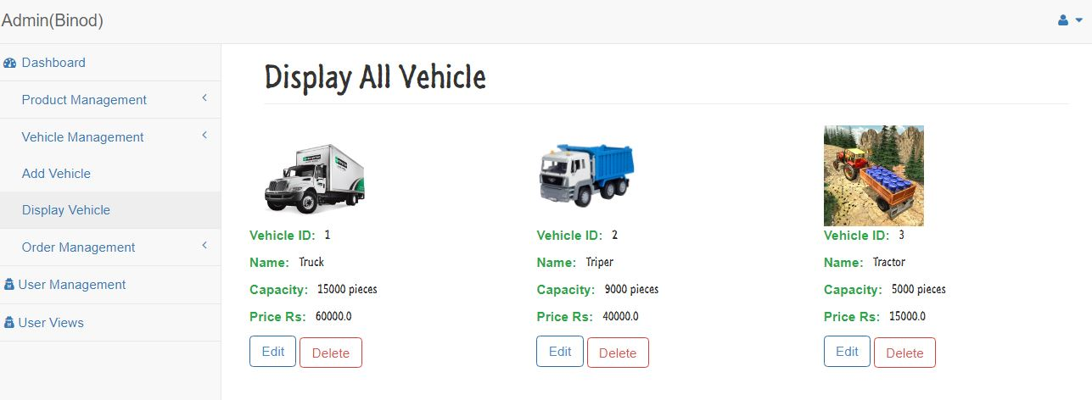

Screenshot: Form to display all vehicle

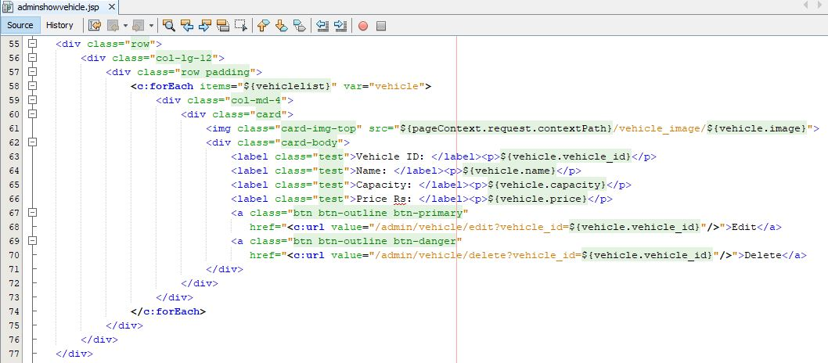

Screenshot: JSP file to display vehicle

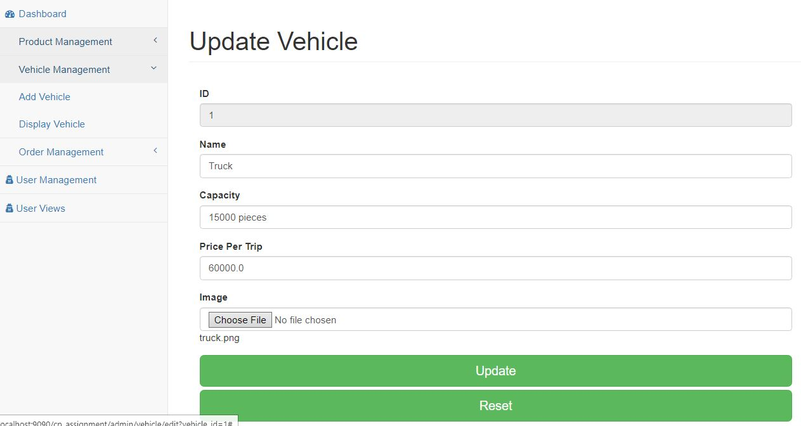

Screenshot: Form to update vehicle

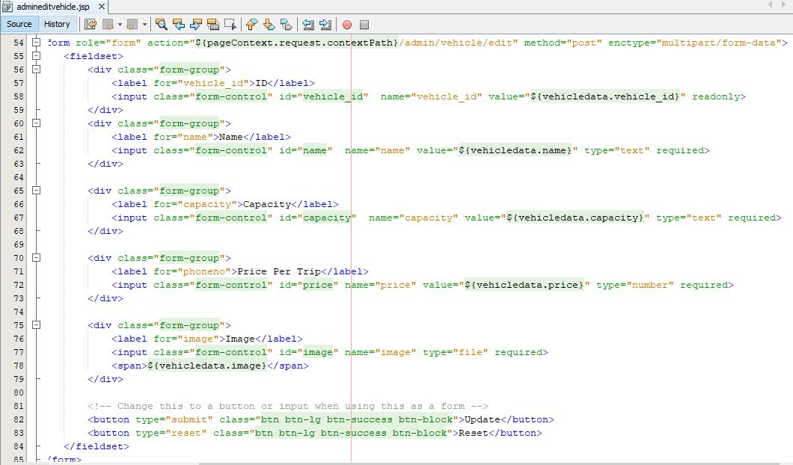

Screenshot: JSP file to edit vehicle

Admin User Manager

Controller to manage user by admin

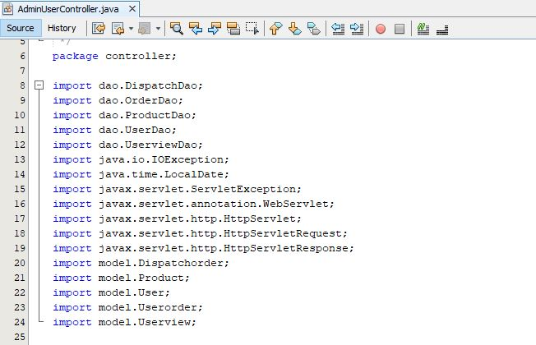

Screenshot: Required imported library for user controller

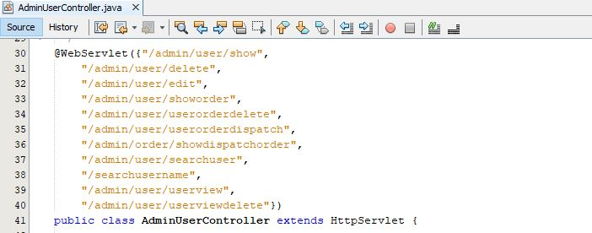

Screenshot: URL(Uniform Resources Locator) for admin user controller

User controller request in doGet and operation performed

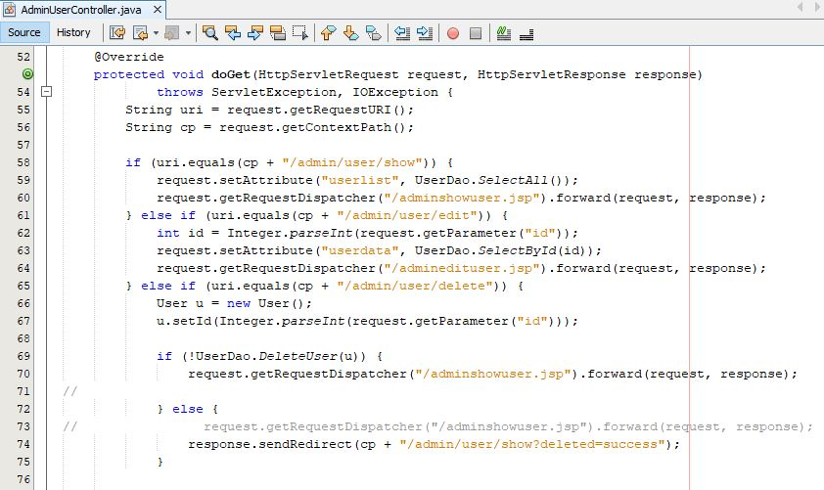

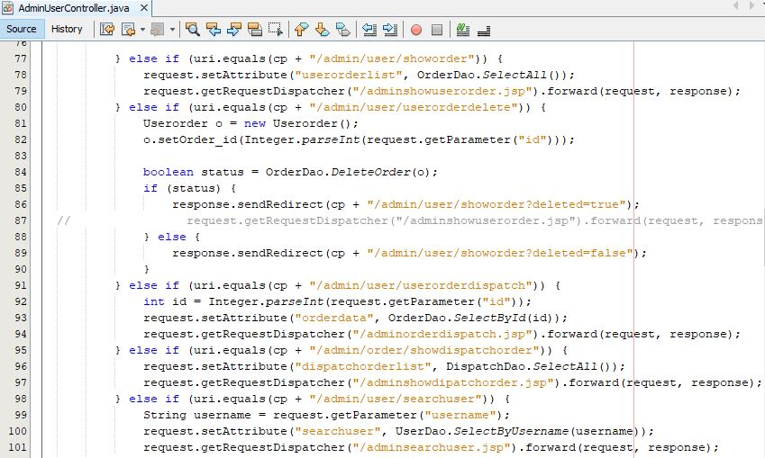

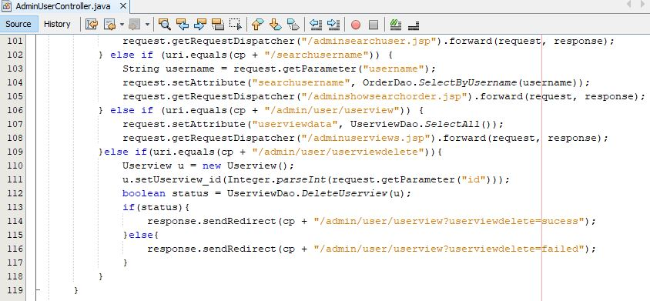

Form to manage user by admin

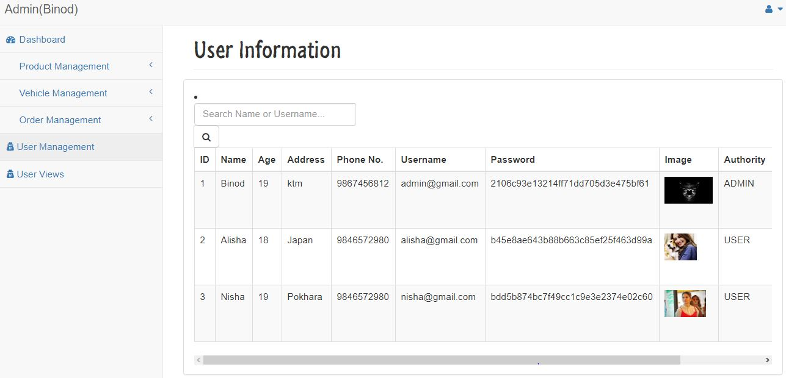

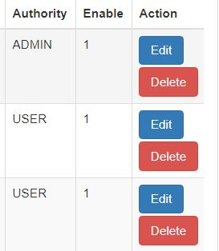

Screenshot: Form showing all user

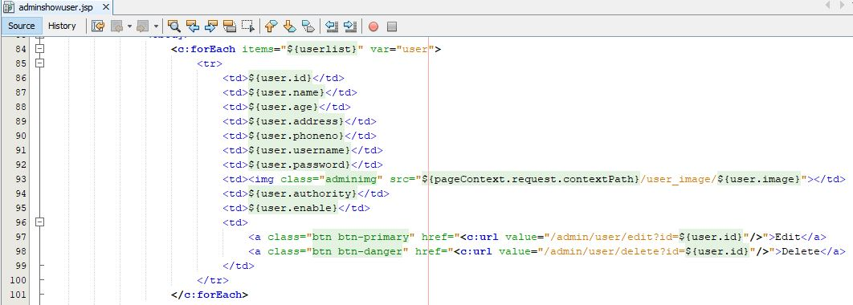

Screenshot: JSP file to display all user

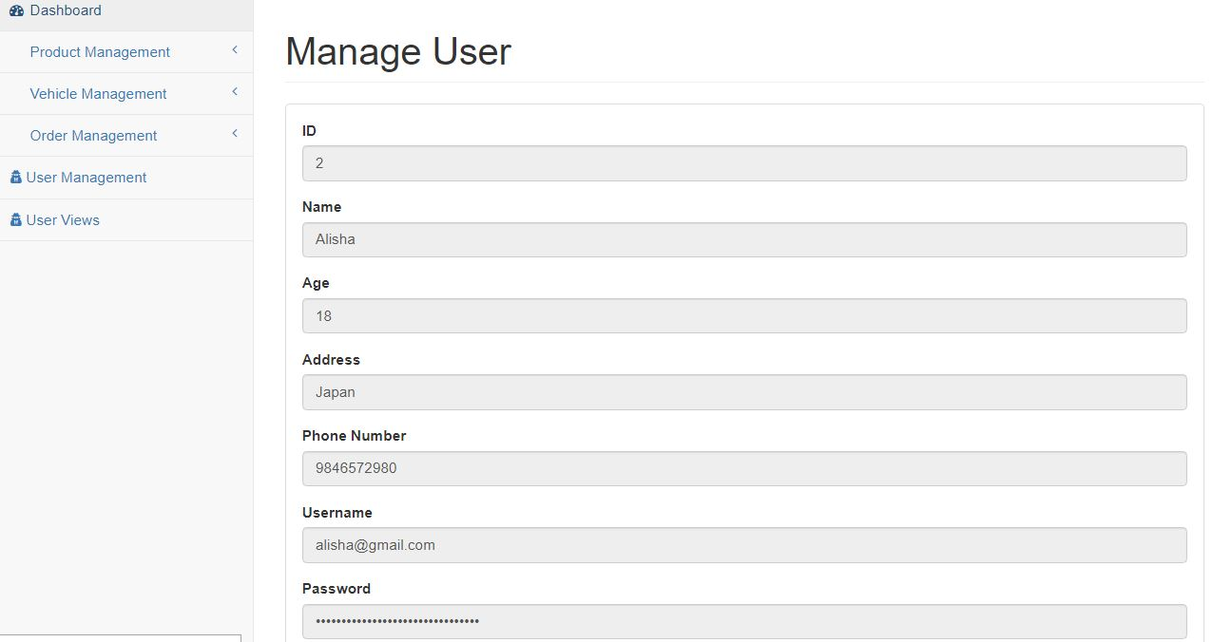

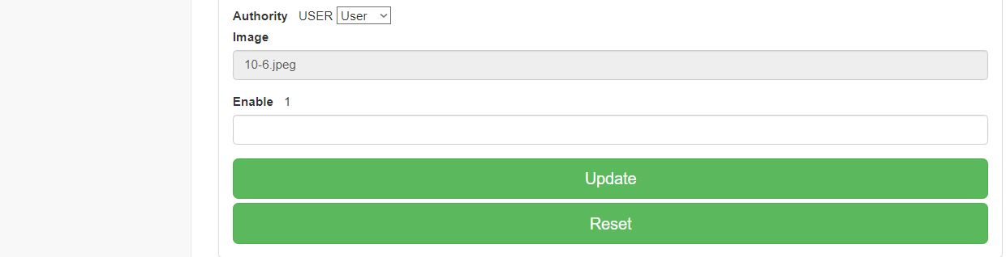

Screenshot: Form to update user by admin

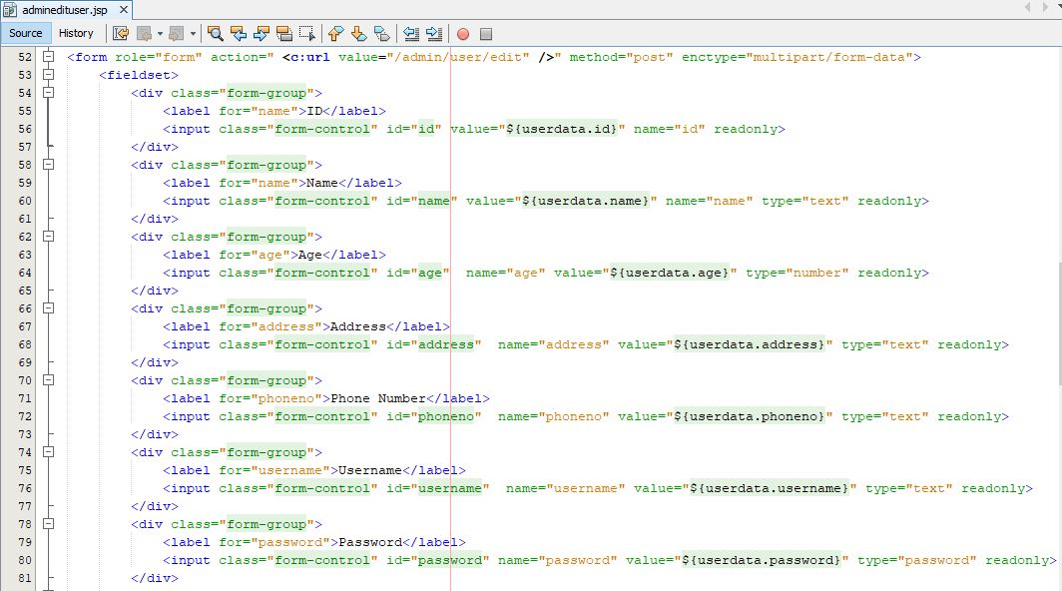

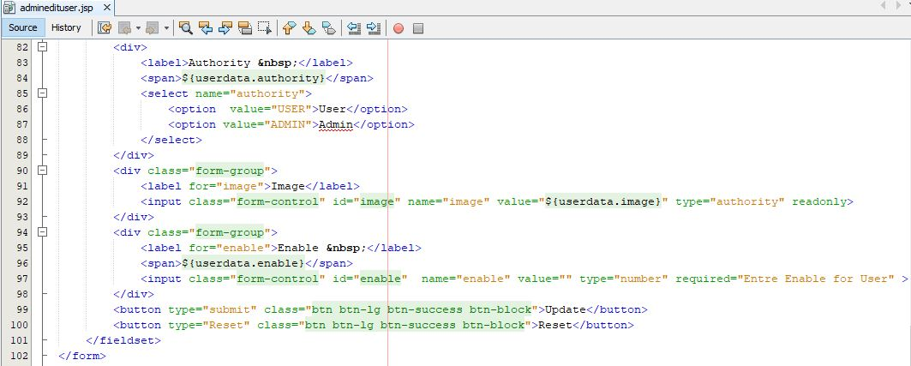

Screenshot: JSP file to update user by admin

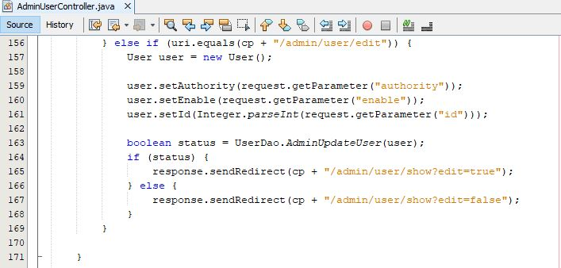

Screenshot: Controller to edit user by admin in doPost

Admin Dispatch Order

Model for dispatch order

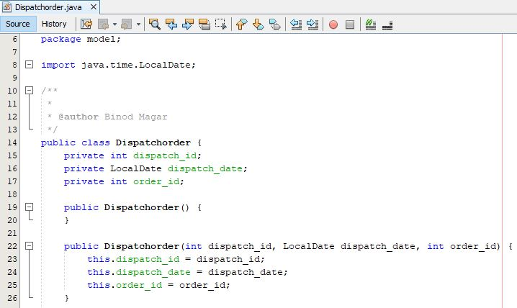

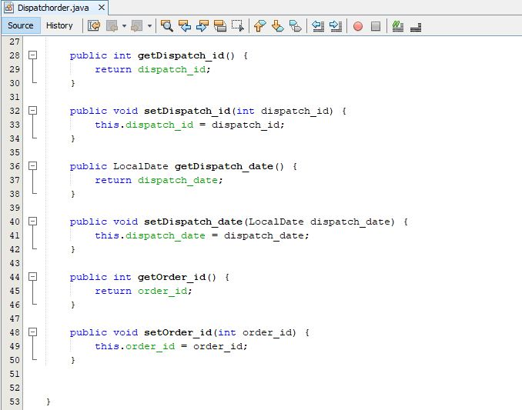

Screenshot: Model to dispatch order and required imported library

Dispatch order Dao(Data access object) for dispatch order

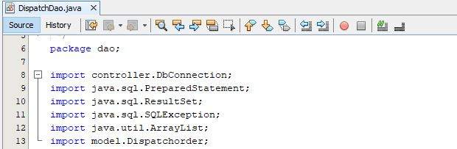

Screenshot: Required imported library for dispatch order dao

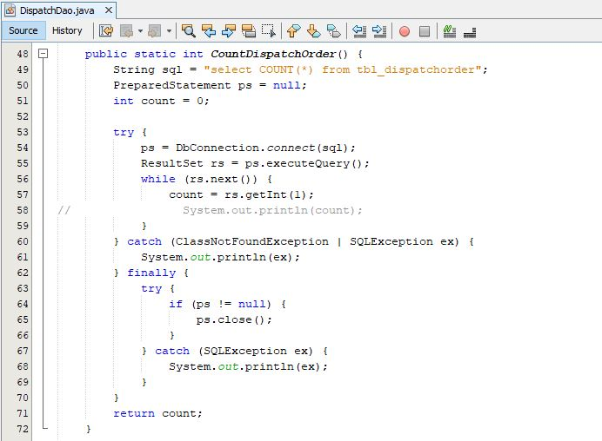

Screenshot: Dao to count all dispatch order

Form of the Dispatch order

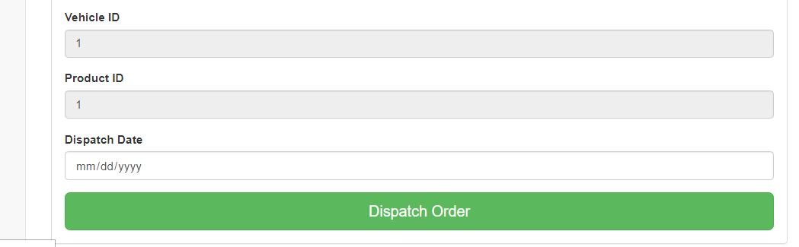

Screenshot: Form to dispatch the order

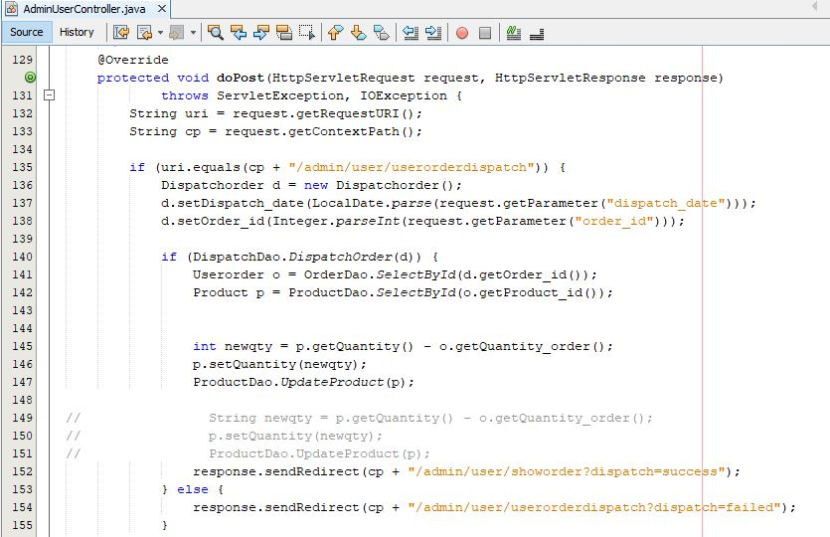

Screenshot: Controller for user order dispatch order

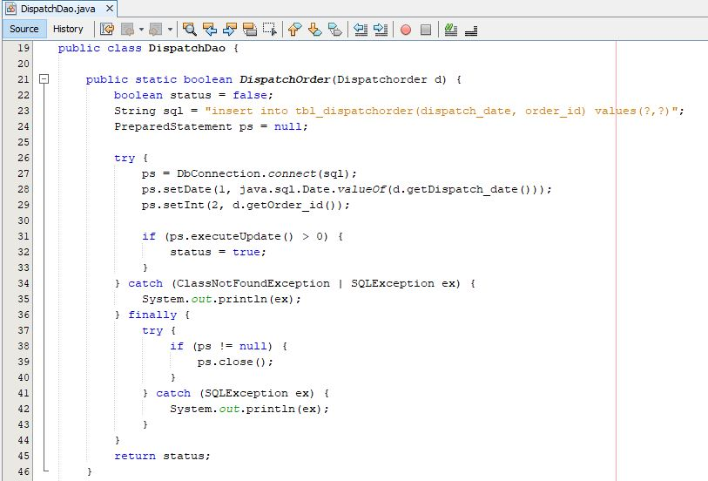

Screenshot: Dispatch dao to insert data of dispatch order in the database

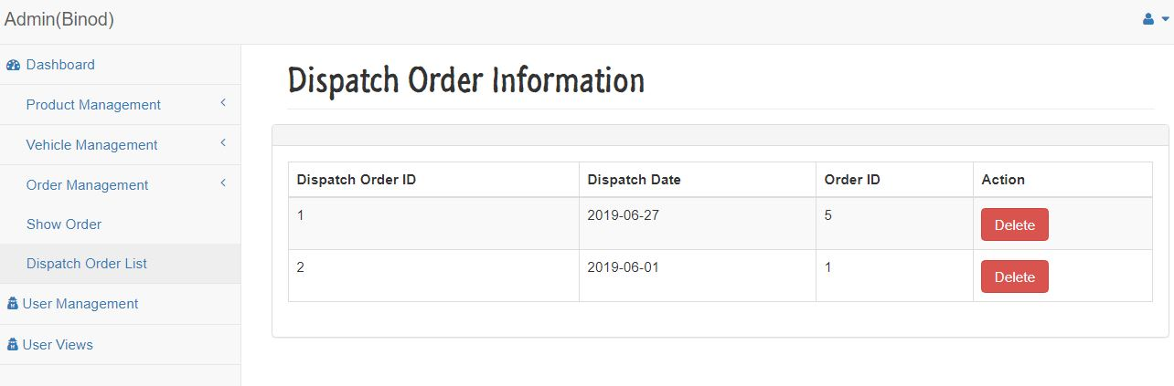

Screenshot: List of all dispatch order

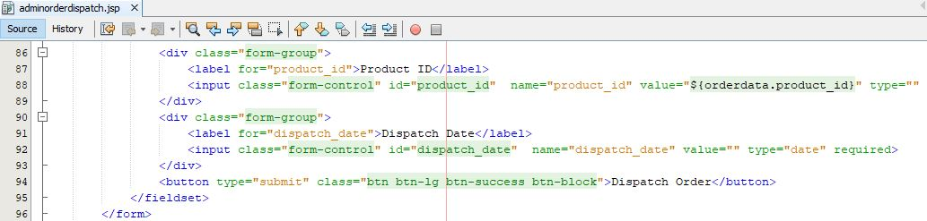

Screenshot: JSP(Java Server Page) to show all dispatch order

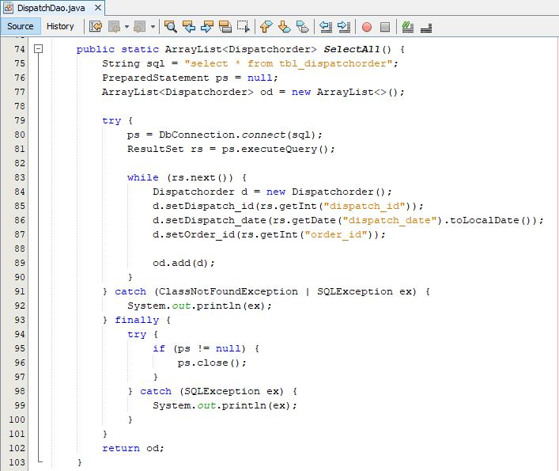

Screenshot: Dispatch dao to select all dispatch order in ArrayList

Index page

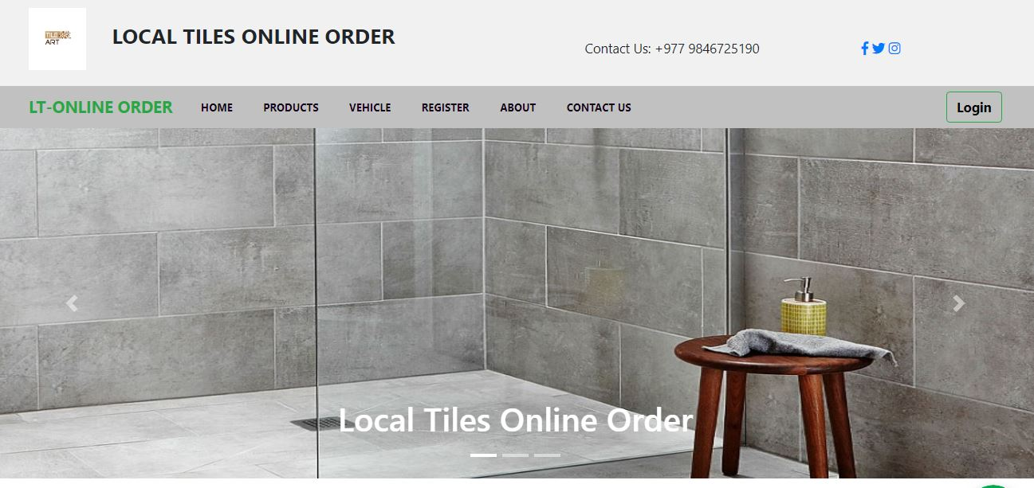



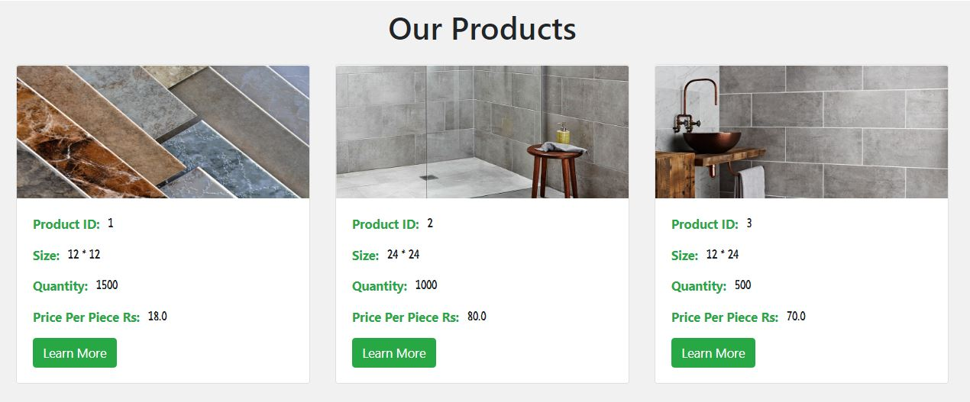

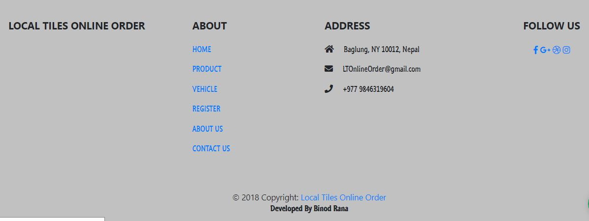

Screenshot: Home page

Controller for index page

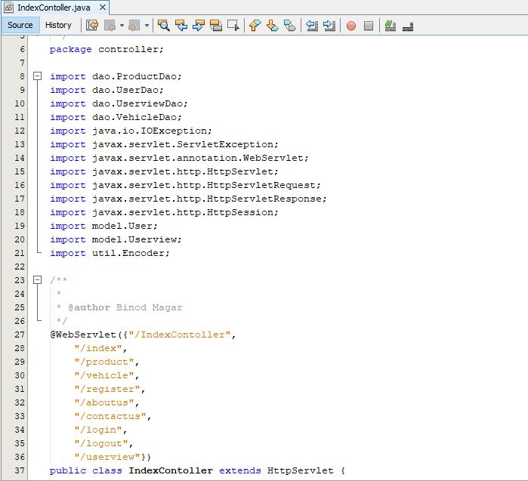

Screenshot: Required imported library and URL(Uniform Resources Locator)

Index controller doGet request and operation performed

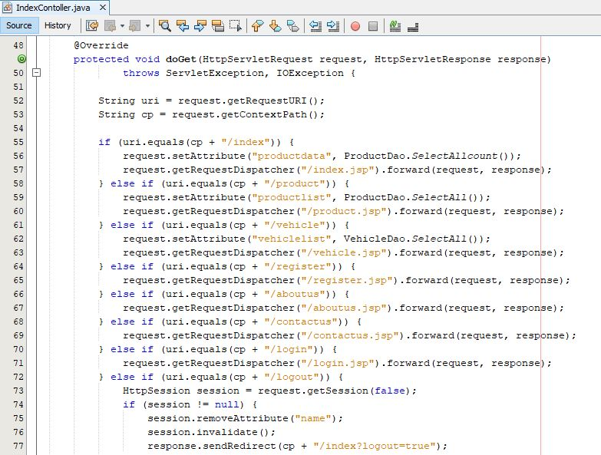

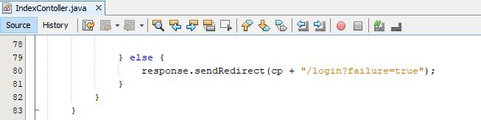

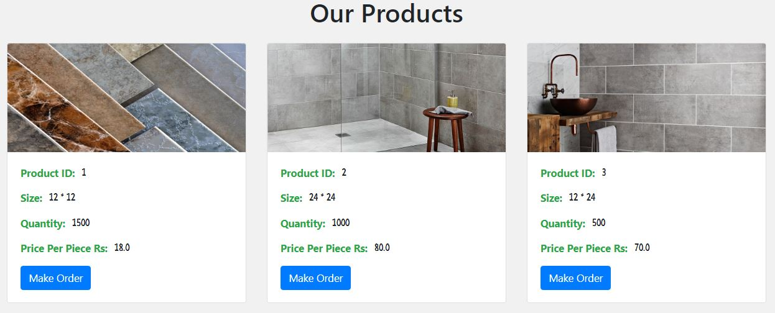

Screenshot: Our product pages

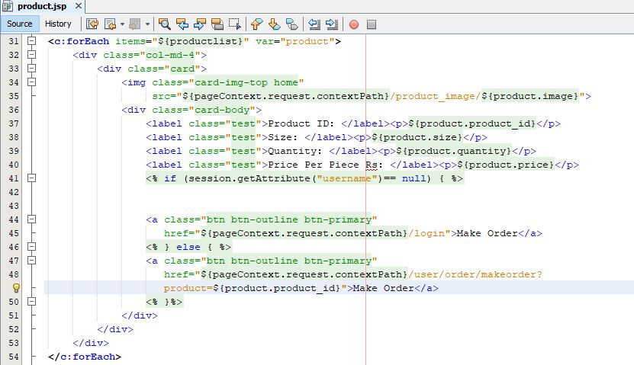

Screenshot: JSP file of our product page



Screenshot: ProductDao to select all product in ArrayList

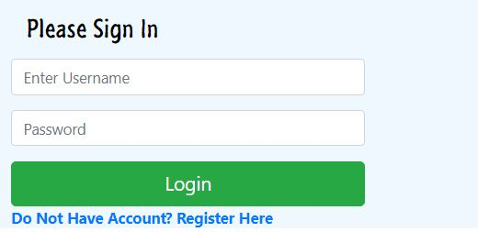

Screenshot: Login form

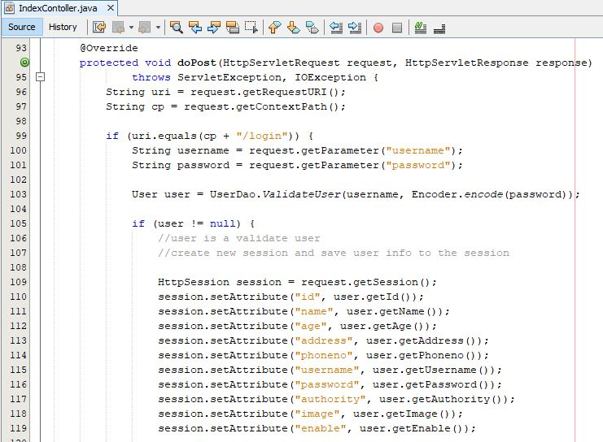

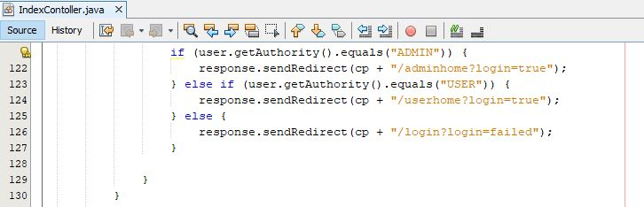

Screenshot: Controller for login

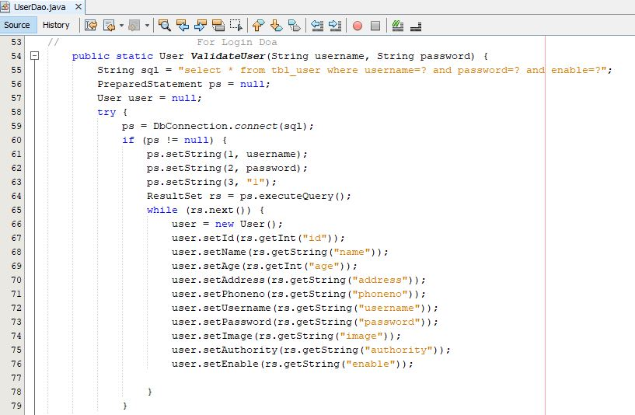

Screenshot: User dao to validate user

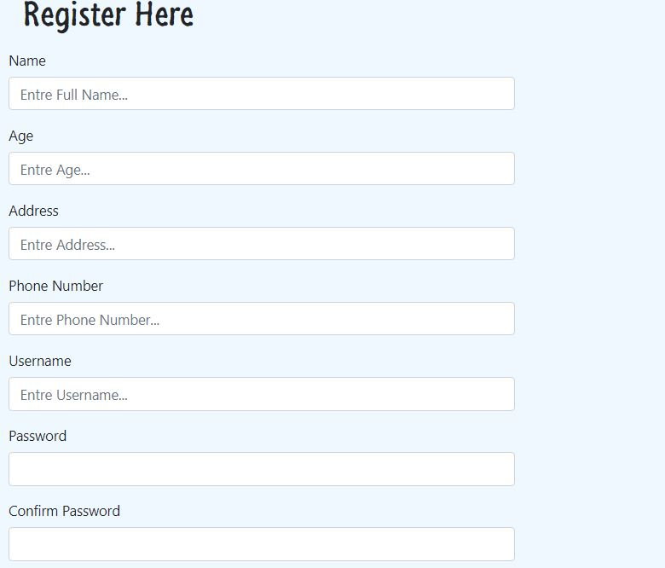

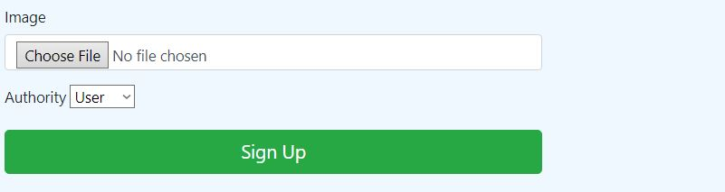

Screenshot: Register form

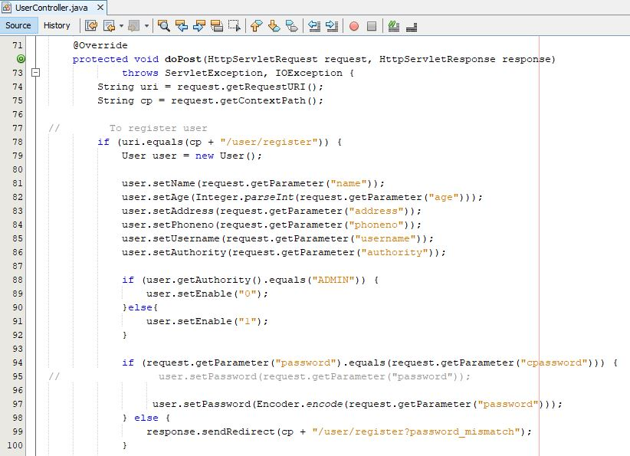

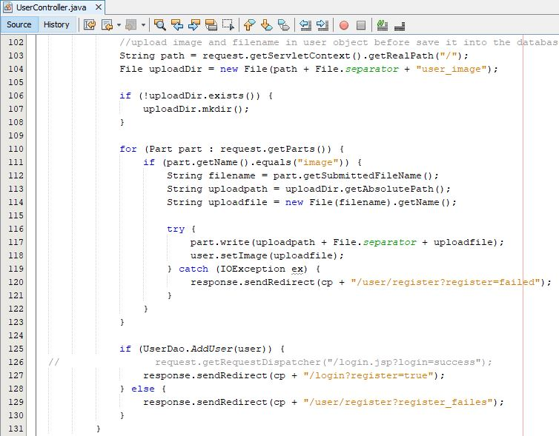

Screenshot: User controller for register user

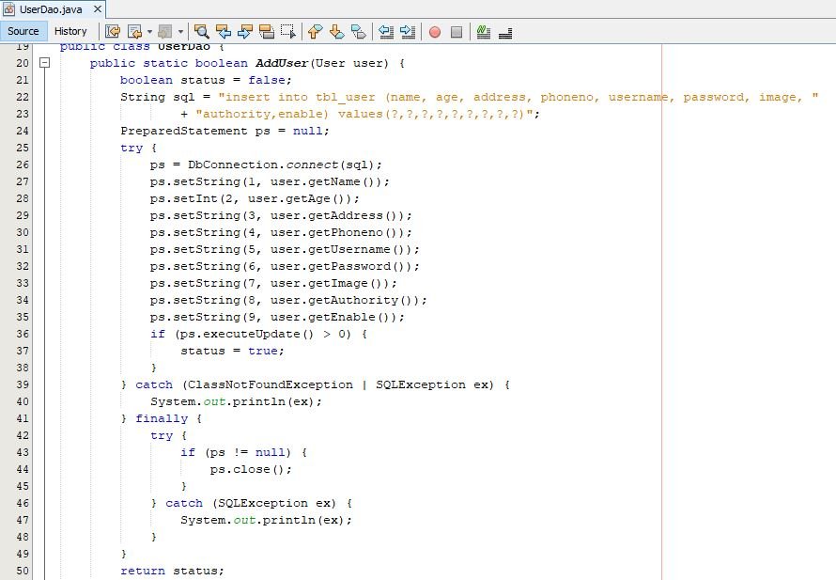

Screenshot: User dao to insert data into database

Model for User

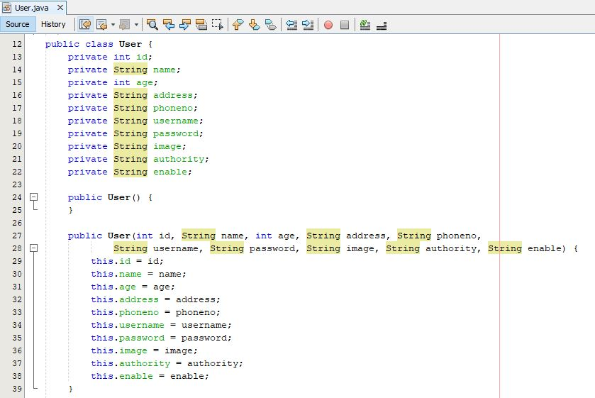

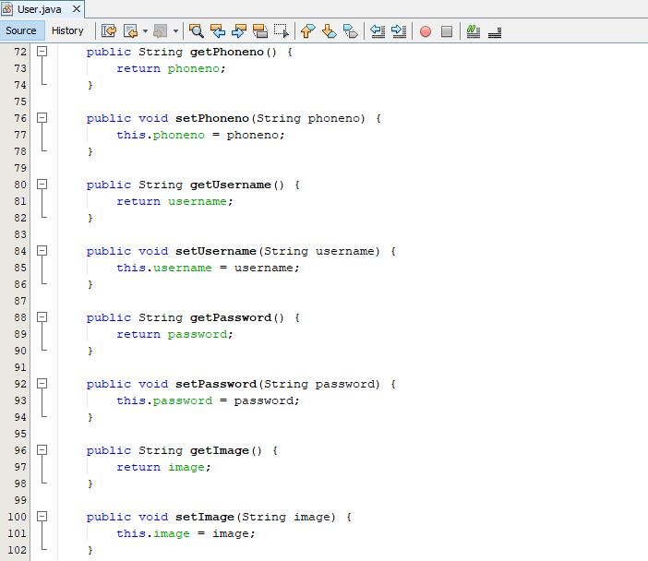

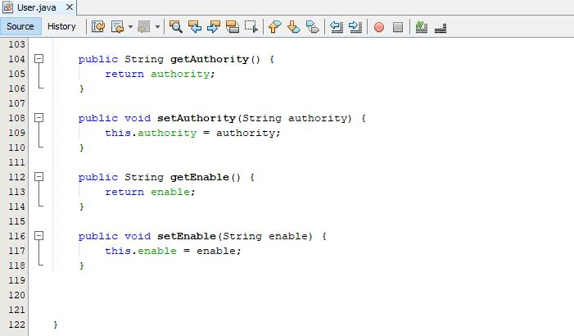

Controller for User profile

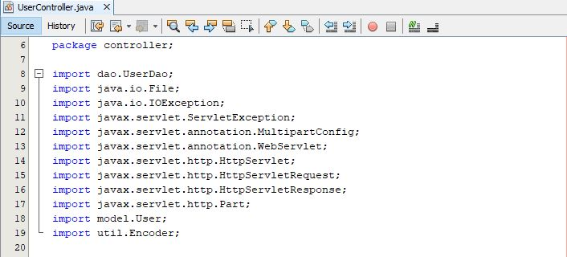

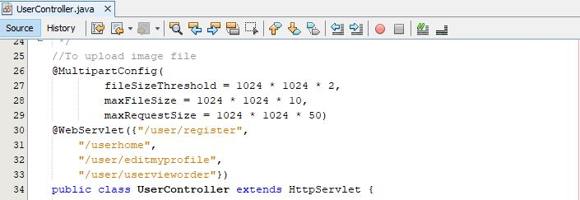

Screenshot: Imported library and URL pattern for user profile

User controller doGet request and operation performed

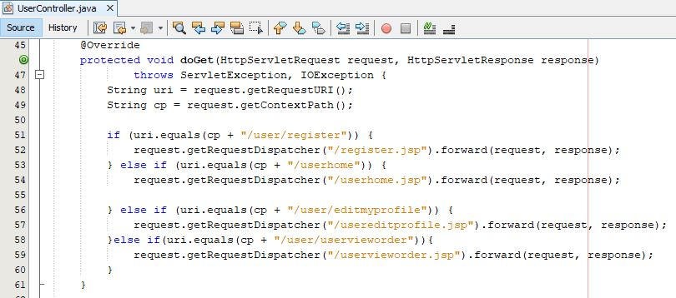

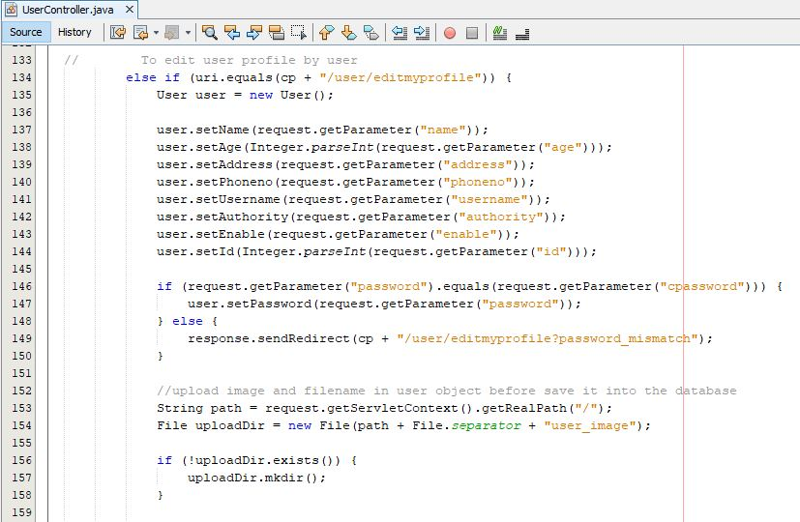

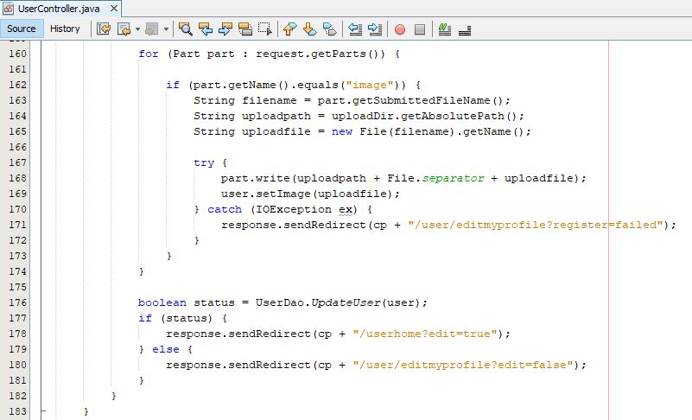

Screenshot: Controller for user edit profile

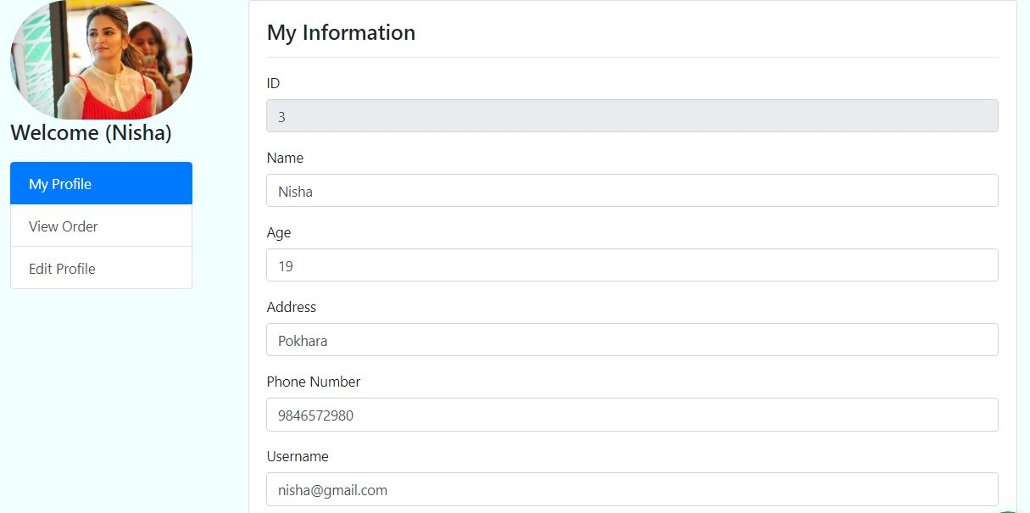

Screenshot: User profile

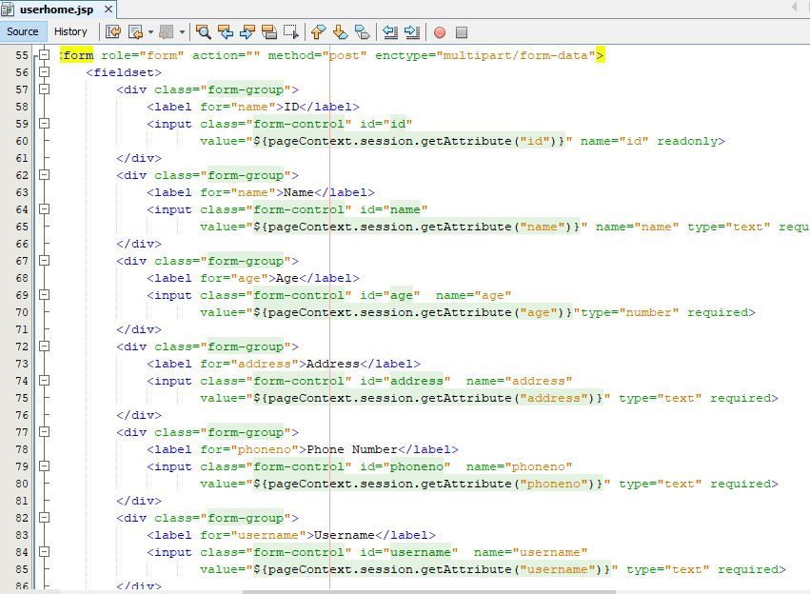

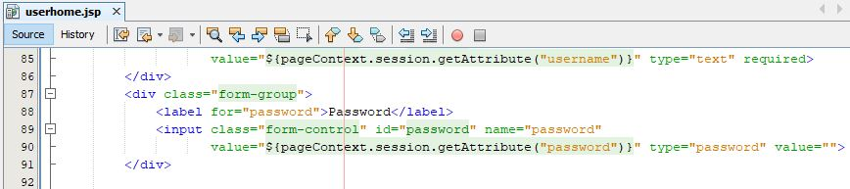

Screenshot: JSP file for user profile

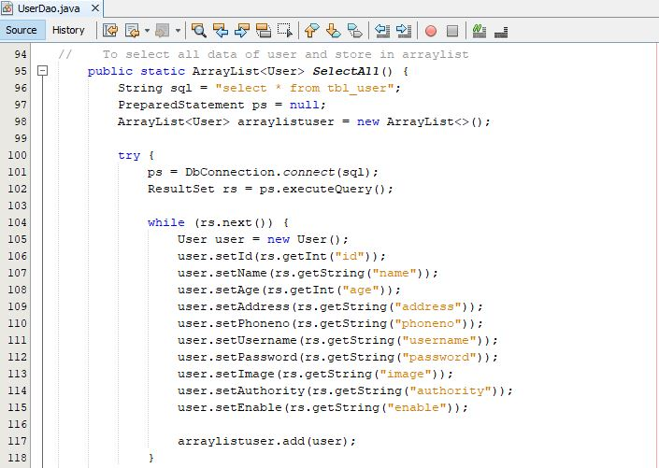

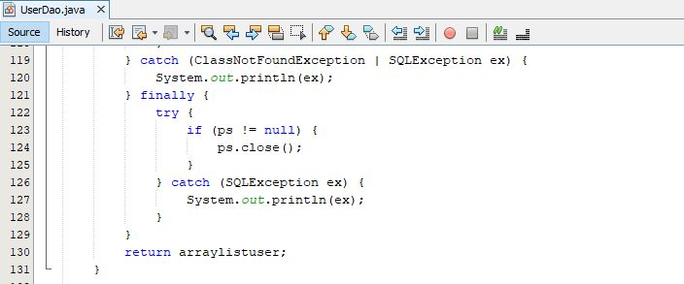

Screenshot: User dao for user show profile

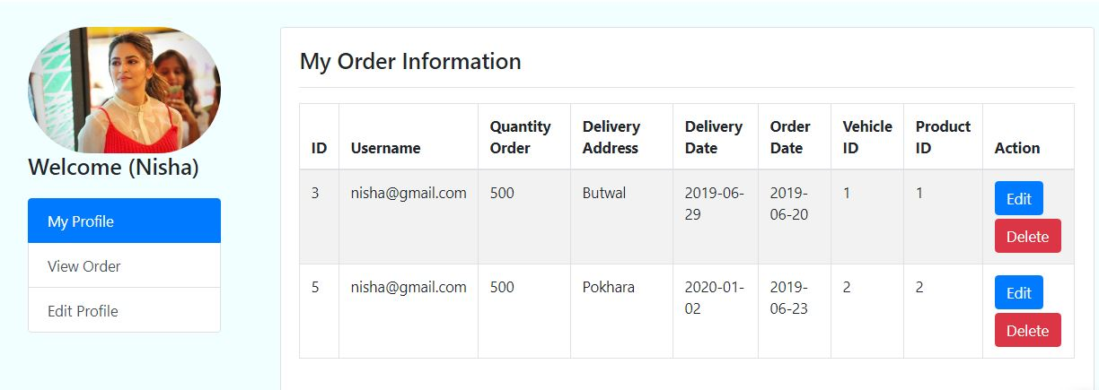

Screenshot: User show order

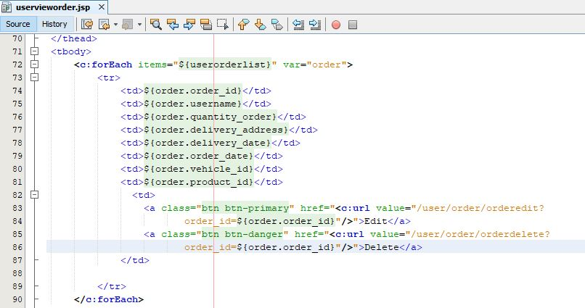

Screenshot: JSP file to show order

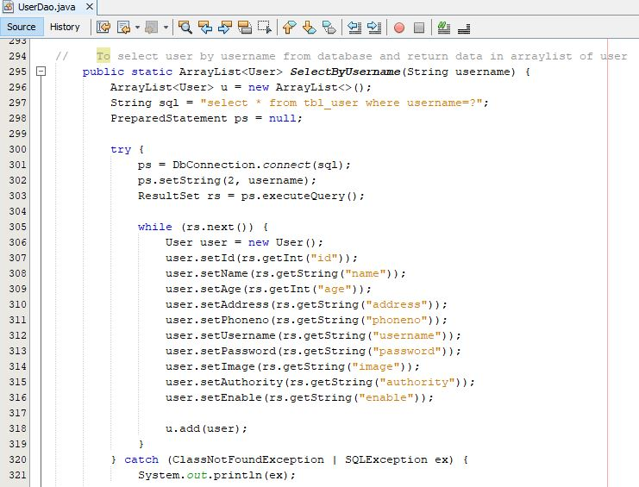

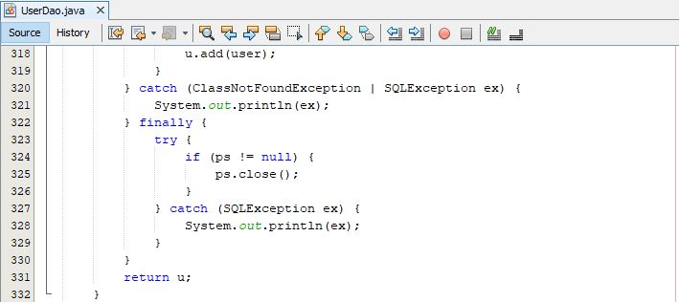

Screenshot: User dao to display order

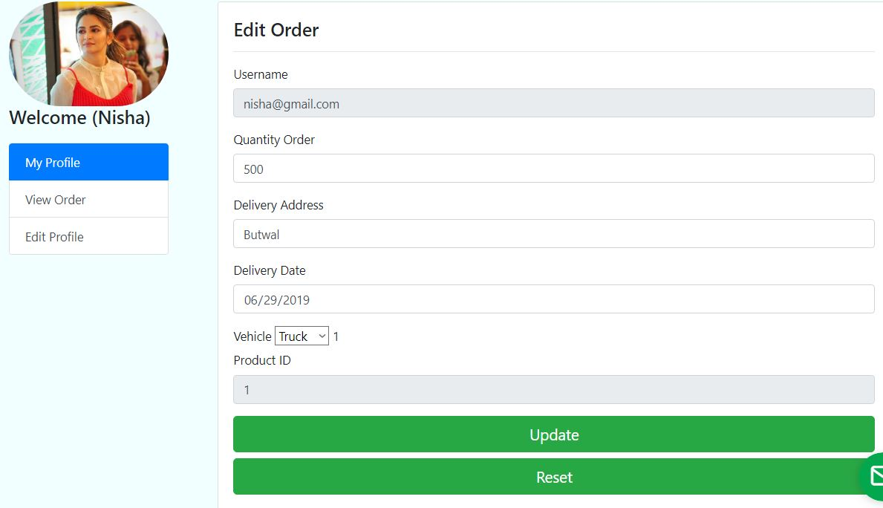Screenshot: User order edit form

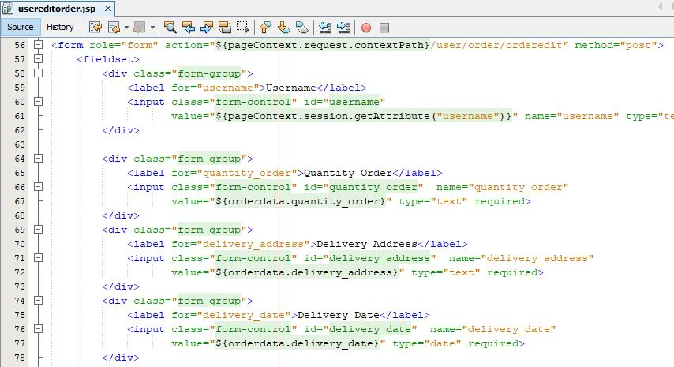

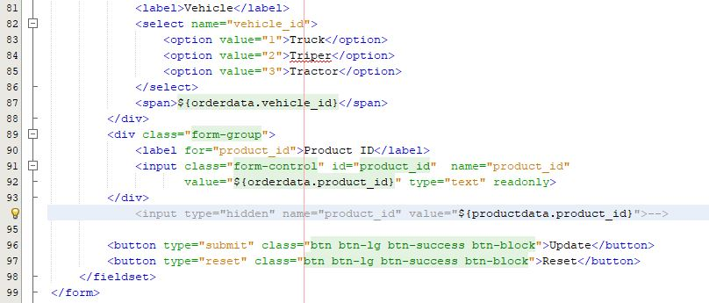

Screenshot: JSP file of user edit form

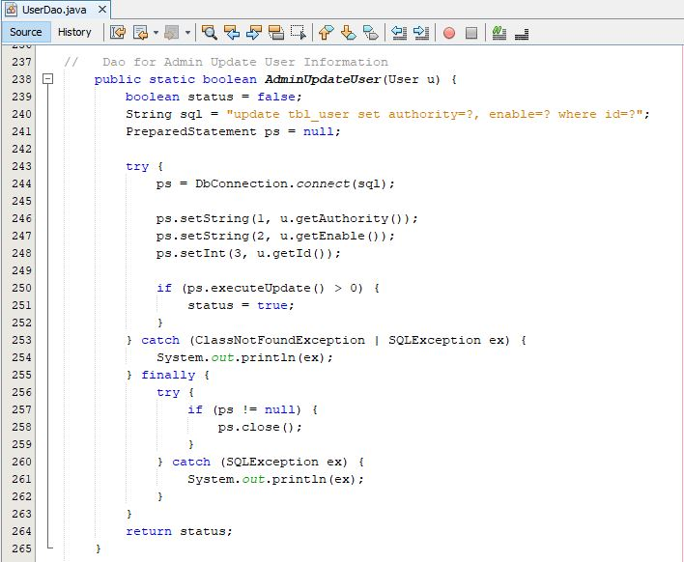

Screenshot: User dao to update

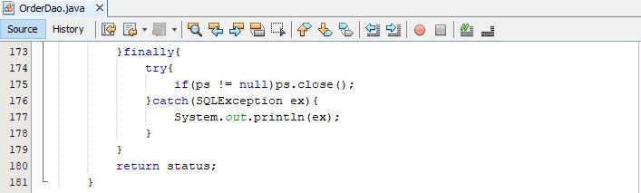

Screenshot: User order edit